UNIT 2: MIDDLE EAST – Geography & Culture NAME: _________________________________________

SS7G8 The student will describe the diverse cultures of the people who live in Southwest Asia (Middle East).
c. Compare and contrast the prominent religions in Southwest Asia (Middle East): Judaism, Islam, and Christianity.

Essential Question: How are the religions of Judaism, Christianity, and Islam similar to one another?
- All three religions are ___________________________ , which means they believe in only __________ god.

- All originated in the __________________________ region, and the city of ____________________________ is historically important.

- All three religions have ____________________ to other continents through migration, trade, and conquest.
ISLAM

Founder:

Date of Origin: Circa _____________ C.E. / AD

Place of origin:

Name of Followers:

Religious Text / Book:

Place of Worship:

Titles of Religious Figures:

Religious Holidays:

Religious symbols: Some Muslims do not recognize the crescent moon and star as a symbol of Islam. Others use calligraphy styled writing, and the use of animals or living things are forbidden to represent Islam.
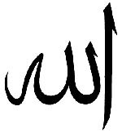
JUDAISM

Founder:

Date of Origin: Circa _____________ B.C.E. / BC

Place of origin:

Name of Followers:

Religious Text / Book:

Place of Worship:

Titles of Religious Figures:

Religious Holidays:

Religious symbols:
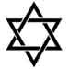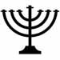
CHRISTIANITY

Founder:

Date of Origin: Circa _____________ C.E. / AD

Place of origin:

Name of Followers:

Religious Text / Book:

Place of Worship:

Titles of Religious Figures:

Religious Holidays:

Religious symbols:
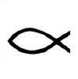

Essential Question: How are the religions of Judaism, Christianity, and Islam different from one another?

