**Unit 4 Test Study Guide**

**SS7G1**

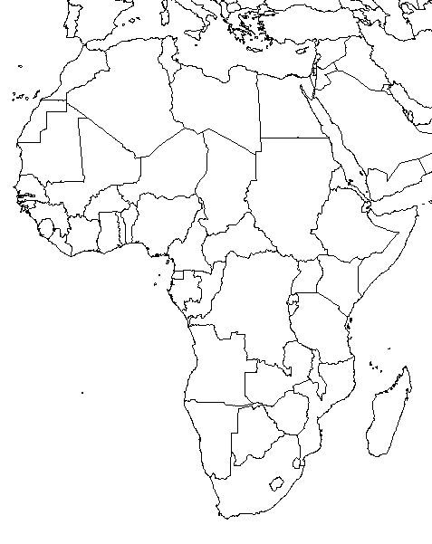



1. Egypt 2. Sudan 3. Kenya 4. Rwanda

5. Zimbabwe 6. South Africa 7. Democratic Republic of Congo

8. Nigeria 9. Sierra Leone 10. South Sudan



11. Atlas Mountains 12. Nile River 13. Sahara 14. Sahel

15. Savanna 16. Tropical Rain Forest 17. Niger River 18. Congo River

19. Lake Victoria 20. Lake Tanganyika 21. Kalahari Desert

**SS7G2**

* Water pollution and its unequal distribution on the continent is a major environmental issue in Africa. Although usual causes exist such as industrial waste, oil spills, and man-made fertilizers, **the biggest cause of water pollution in Africa is** from natural environmental factors such as worms, larvae, bacteria and other parasites that grow and breed in standing water which many people in rural areas are forced to use.
* Less than 50% of the population in sub-Saharan Africa has access to safe drinking water which can lead to disease, poor crop harvests, famine, and even poor economic growth.
* Although water pollution is a major problem, some African governments ignore industrial pollution of waterways. They want their industries to make more profits and to crack down on industries that pollute would hurt their national economy.
* Deforestation is another environmental issue on the continent. The results of deforestation can include the soil becoming useless for farming, erosion, and flash floods when it does actually rain. Although most Africans are aware of the negative effects, they often have little choice but to continue down this road. They often cut down forests for the money they can get from the timber, to clear more land for farming, for heating and cooking, and for building to keep up with a growing population.
* One other environmental issue discussed in class is desertification which is the process of once arable land turning into desert. Overgrazing, poor farming practices, and drought can create this erosion process. As a result, the amount of arable land available to farmers is decreasing rapidly and can lead to famine and related diseases.

**SS7G3**

* Africa has four very different regions of life with unique characteristics that affect where people live, the type of work they do, and how they travel. The population in the Sahara is very low due to the limited access to water. They are primarily nomadic herders who travel from one oasis to another. Travel and trade is very difficult here due to its harsh conditions.
* The Sahel is mostly made up of subsistent farmers with some mining that takes place as well. This is the region suffering from desertification. Desertification has actually driven some herdsmen in the north into the lands of farmers in the south as the Sahara expands, which contributes to conflict in some regions such as Darfur in Sudan. Farmers often have to move to find new arable lands in this arid climate. Some in the Sahel region are trying reforestation projects to prevent the desert from expanding further. Travel and trade is easier here than in the harsh Sahara or thick Tropical Rain Forest even though water can be hard to find in many areas of the region.
* The Savanna is the most densely populated due to people being able to live off the land. Many are subsistent and cash crop farmers. There is some mining here as well, and a number of cities are located here near water sources which creates many other types of jobs. It is easier for travel and trade in this region than the Sahara and Tropical Rain Forest.
* The Tropical Rain Forest is densely populated in parts but somewhat sparsely populated overall due to the thick forests. People survive off the timber industry as well as mining and commercial farming. Travel and trade is difficult due to the thick forests so the rivers are often used as a way to get from one place to another in the region.
* Regardless of the region, you can find most of the cities in Africa located near the coast or other major waterways. People migrate to these industrial centers for the jobs they provide. Industries locate there so they can import and export their goods more easily. The sources of water can also provide hydroelectricity as well as a place for dumping industrial waste.

**SS7G4**

* Ethnic groups share a common set of characteristics such as customs, traditions, language, and even some physical traits but often practice a variety of religions. Religious groups share a common set of beliefs and are usually made up of multiple ethnic groups. Neither of these types of groups is defined by political borders (confined to one specific country).
* We discussed four ethnic groups in class, one of which was the Arabs. The Arabs are primarily located in North Africa and are descendants of people who originated in the Arabian Peninsula. Their most common religion is Islam although some practice Christianity as well.
* The Ashanti are primarily located in West Africa, in and around the country of Ghana. Their most common religion is traditional beliefs which include beliefs in the supernatural or mystical, including the origins of the Golden Stool which has come to represent Ashanti unity. They believe in one supreme being capable of taking on many forms. Many also practice Christianity or Islam.
* The Bantu are located throughout sub-Saharan Africa with traditional beliefs being the most common. These traditional beliefs vary depending on the region but include animism (the belief that all things have a soul or spirit) and the belief of the spirits of ancestors being present in everyday life. Many Bantu have come to practice Christianity, Islam, or other religions. They are credited with one of the greatest migrations over time in human history. During this period, they are responsible for the spread of iron skills and the impact on sub-Saharan languages.
* The Swahili are primarily located along the east coast of Africa. The Swahili have a mix of Bantu and Arab ancestry so it is no surprise that they commonly practice a mixture of Islam and traditional beliefs. For example, men will wear traditional amulets around their neck containing verses from the Qur’an (religious text of Islam) to protect them from evil.